# PeopleSafe - National Provider Identifier (NPI)

NPI’s with Test Claims

Related Documents

**Description:** Information about the National Provider Identifier that is assigned to healthcare providers used when running a Test Claim and how to validate.

|  |
| --- |
| NPI’s with Test Claims |

In accordance with HIPAA regulations, healthcare providers use a National Provider Identifier (NPI).

* If a prescriber sends an electronic transaction the NPI will be required (for payment, e-prescribing etcetera.). Prescribers have the NPI printed on their prescription pads.
* If the pharmacy receives the NPI, they are obligated to submit it on the claim.
  + - All provider requests that do not contain the NPI will be rejected.
    - NPI consists of 10 numeric characters (numbers only).
    - Fields are labeled NPI/NCPDP. (The older acronym for “National Council for Prescription Drug Programs” was superseded by the NPI.)

**Note:** Not all clients require an NPI/NCPDP number to be entered when running a Test Claim. If the client does not require this detail, then there will be no need to populate this information.

When processing a **Test Claim**, utilization of the NPI is required as noted below:

|  |  |
| --- | --- |
| If the CCR uses the... | Then PeopleSafe will automatically change…. |
| NCPDP | NCPDP to the assigned NPI. |

**Notes:**

* If the NPI has not yet been assigned then there will be no translation until the NPI is received for the provider.
* The NPI for the Caremark Mail Order Pharmacy are as follows:
  + Wilkes-Barre, PA (WBP): 1326029232
  + Chicago, Illinois (CHI): 1629341177
  + San Antonio, Texas (SAT): 1841271764
  + Honolulu, HI (HIP): 1578836698
  + Phoenix, Arizona (PHX): 1841271756

* The NPI for Caremark Specialty Pharmacy is 1134100134.
* To validate NPI numbers for a specific pharmacy, refer to <https://npiregistry.cms.hhs.gov/>

**Illustration:**

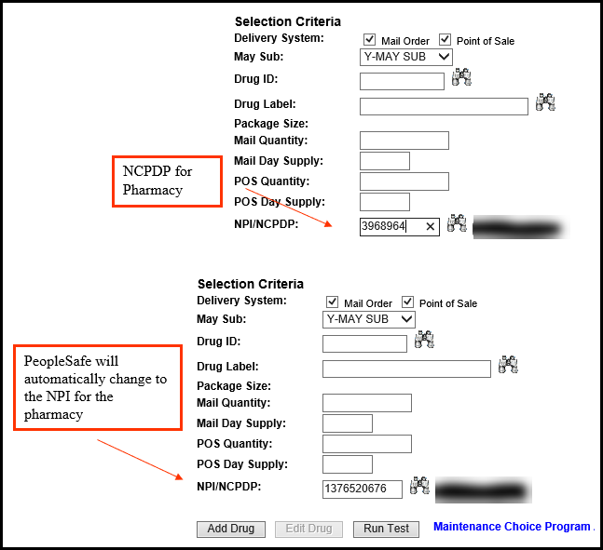

Top of the Document

|  |
| --- |
| Related Documents |

[Customer Care Abbreviations, Definitions, and Terms Index (017428)](https://thesource.cvshealth.com/nuxeo/thesource/#!/view?docid=c1f1028b-e42c-4b4f-a4cf-cc0b42c91606)

**Parent Document:** [CALL 0049 Customer Care Internal and External Call Handling](https://policy.corp.cvscaremark.com/pnp/faces/DocRenderer?documentId=CALL-0049)

Top of the Document

Not To Be Reproduced Or Disclosed to Others Without Prior Written Approval

**ELECTRONIC DATA = OFFICIAL VERSION / PAPER COPY = INFORMATIONAL ONLY**